Microservice Architecture Beauty App Project using Spring Boot, Redis and MySQL
This document describes a proposed microservice architecture for your BeautyApp project, leveraging Redis (as a cache) and MySQL (as the primary data store).
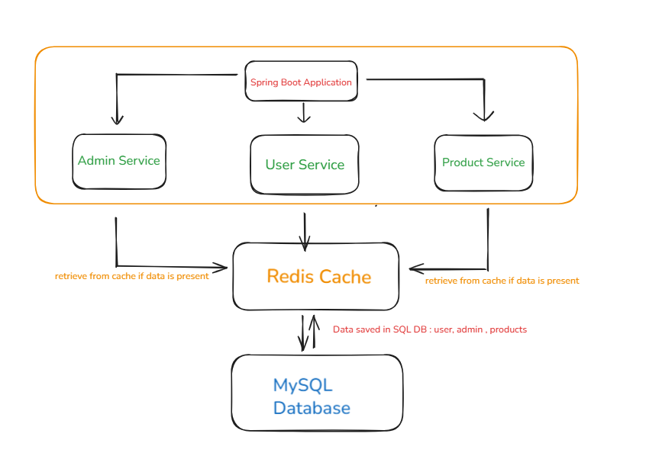

---## 1. Overview
# BeautyApp Spring Boot Application: Docker Compose Deployment Guide
This guide explains how to deploy your [pranjaljoshinagarro/beautyappproject] (https://github.com/pranjaljoshinagarro/beautyappproject)

Spring Boot application using the provided `docker-compose.yml`. The architecture includes your main app, MySQL as the relational database, and Redis as the caching layer.

**Key Components:**
- User Service
- Admin Service
- Product Service
- MySQL (Database)
- Redis (Cache)
## Technology Stack
| Component | Technology |
|--------------------|-------------------|
| Microservices | Spring Boot |
| Cache | Redis |
| Database | MySQL |
| Containerization | Docker, Docker Compose/Kubernetes |
## Prerequisites

- [Docker](https://docs.docker.com/get-docker/) and [Docker Compose](https://docs.docker.com/compose/) installed.
- Your project folder should contain:
- `docker-compose.yml` (as shown above)
- `init.sql` (if you want to pre-populate your MySQL database)
- (Optional) Access to the Docker registry for the prebuilt images:
- `pranjalnagarro/beautyappprojectmain:beautyappprojectapplication` (app)
- `pranjalnagarro/beautyappproject:beautyappredis` (redis)
Clone the repository:
git clone https://github.com/pranjaljoshinagarro/beautyappproject.git
cd beautyappproject/

## 1. Start All Services
Build and run all services in detached mode:
```sh
docker compose up --build -d
```
- The `--build` flag is only required if you use a local Dockerfile; as your `app` service uses a prebuilt image, it is optional.
- The `-d` flag runs the containers in the background.
### What happens?
- **App service** runs your Spring Boot application.
- **db** service runs MySQL 8.0, with the database `beautyproject`.
- **redis** service runs Redis for caching.
## 2. Verify Services
Check if all services are running:
```sh
docker compose ps
```
You should see containers named `beautyapp`, `beautyapp-mysql-db`, and `beautyapp-redis` all in the "Up" state.

## 3. Access the Application
- Open [http://localhost:8080](http://localhost:8080) in your browser.
- The app should now be live and connected to both MySQL and Redis.

## 4. Stopping and Removing Containers
To stop and remove all containers, networks, and the default network:
```sh
docker compose down
```
##5. Useful Commands to execute in container
- **Connect to the MySQL CLI:**
docker exec -it beautyapp-mysql-db mysql -u root -p
- **Connect to the Redis CLI:**
docker exec -it beautyapp-redis redis-cli
## 6. Troubleshooting
- **App fails to connect to db or redis:**
Ensure the `db` and `redis` services are healthy (`docker compose ps`).
- **Templates not found:**
Ensure your application JAR includes all Thymeleaf template files.
- **MySQL schema doesn't exist:**
Check your `init.sql`, or manually create the schema.

## 9. Reference
- [Sample Aplication Link:]
(https://github.com/SnehalAShinde/Spring_Boot_Project/tree/master)
- [Docker Compose documentation](https://docs.docker.com/compose/)
- [Spring Boot Docker guide](https://spring.io/guides/gs/spring-boot-docker/)
Advance Assignment:
• Take an existing Dockerfile and optimize it for build speed and image size
I was using beauty-app-project which is of 478 MB in size and then I used alpine image as in Dockerfile and then later created a new image named docker.io/library/beauty-app-project-new-optimize:v2 which is 245 MB in Size , it significantly been reduced by 48%
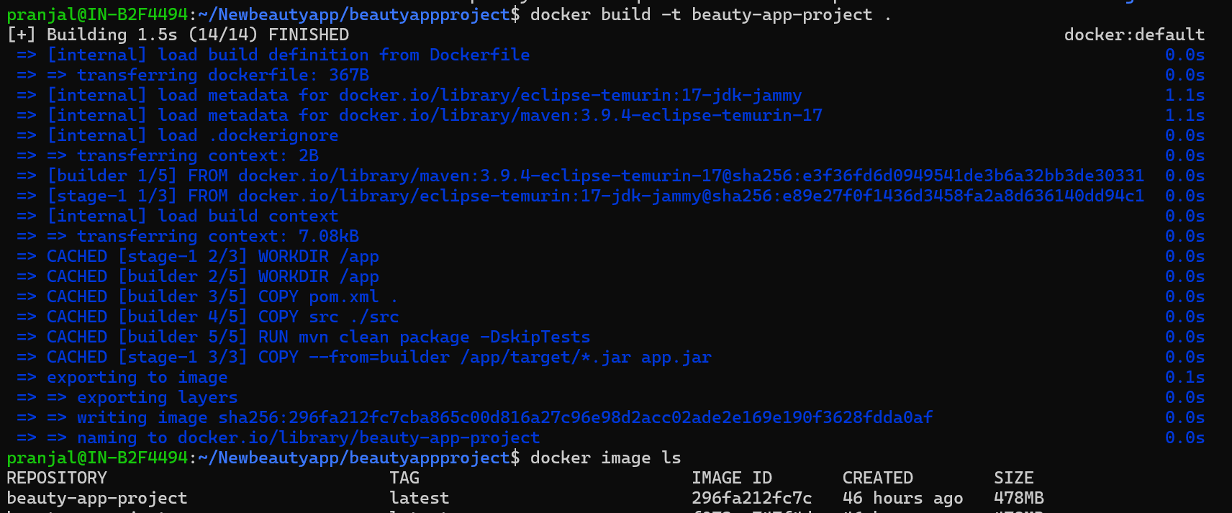
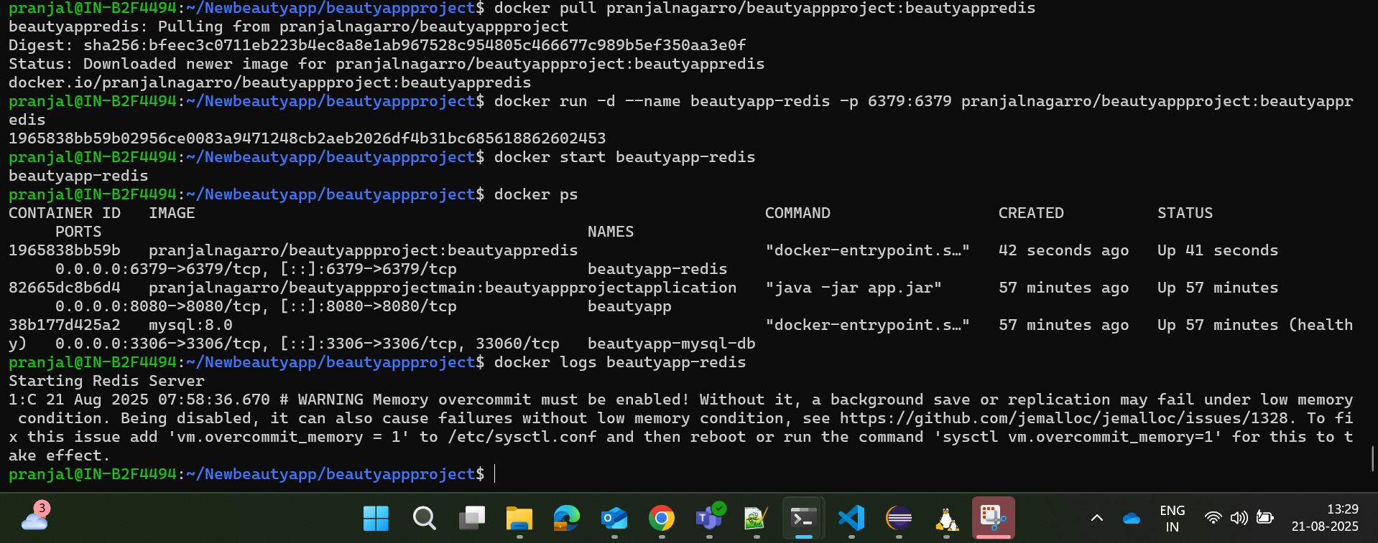
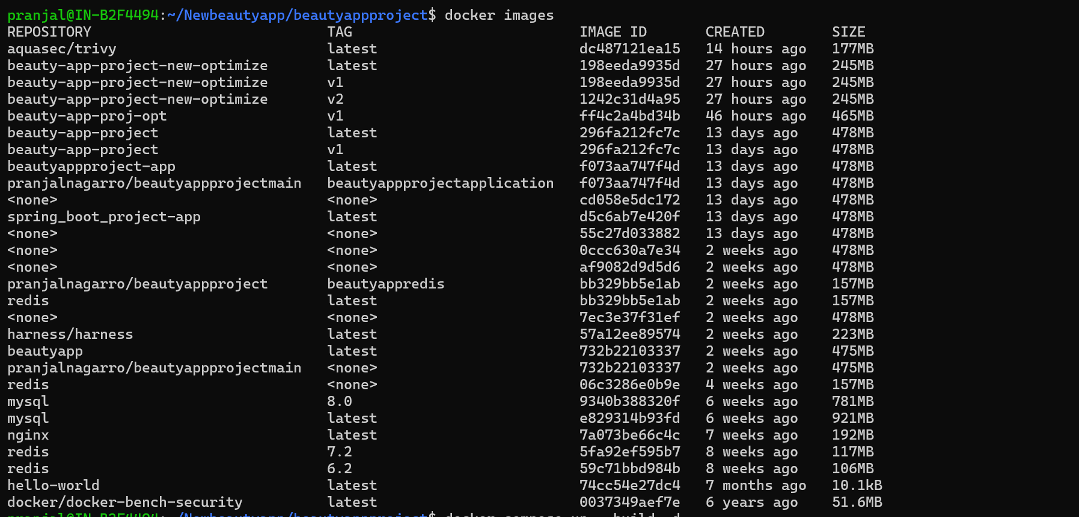
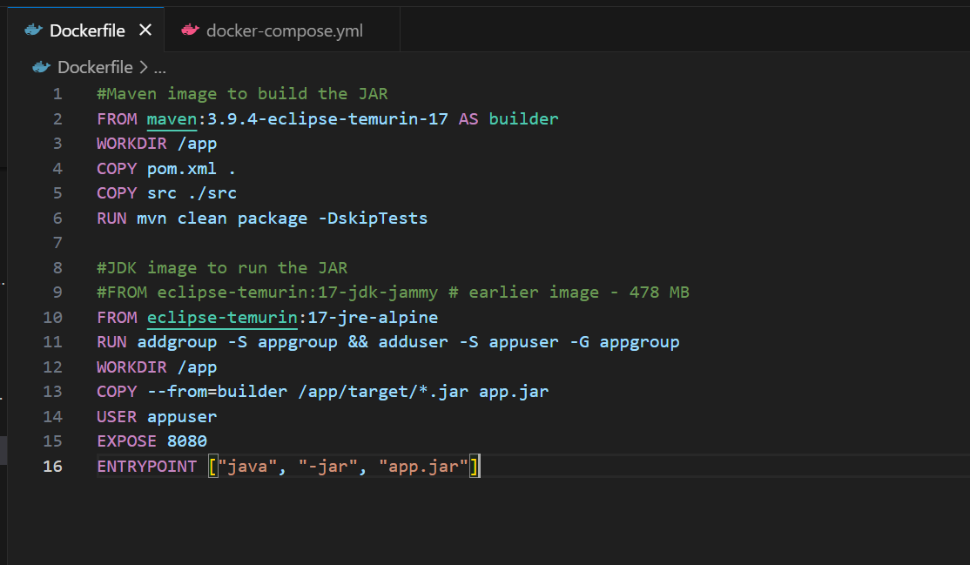
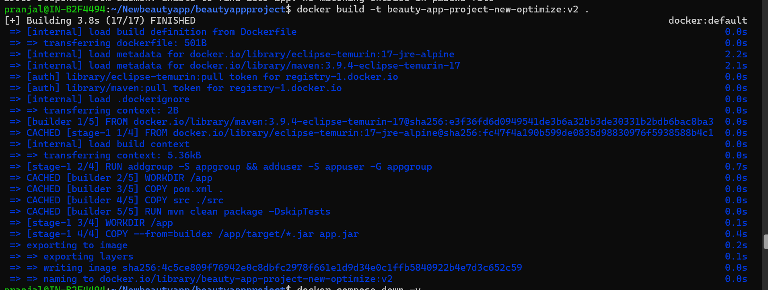
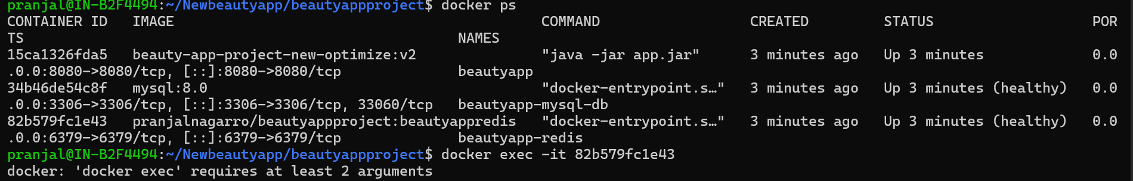
• Use multi-stage builds where appropriate.
Used multi-stage builds in Dockerfile maven image to build the JAR file. Then JDK alpine image to run the JAR file only.

• Set up a custom Docker network and connect multiple containers to it.
Created Docker Network named “beautyapp-network” for my application and connected my application, database and redis with that network performed various commands such as inspect, connect etc. for custom docker network setup.
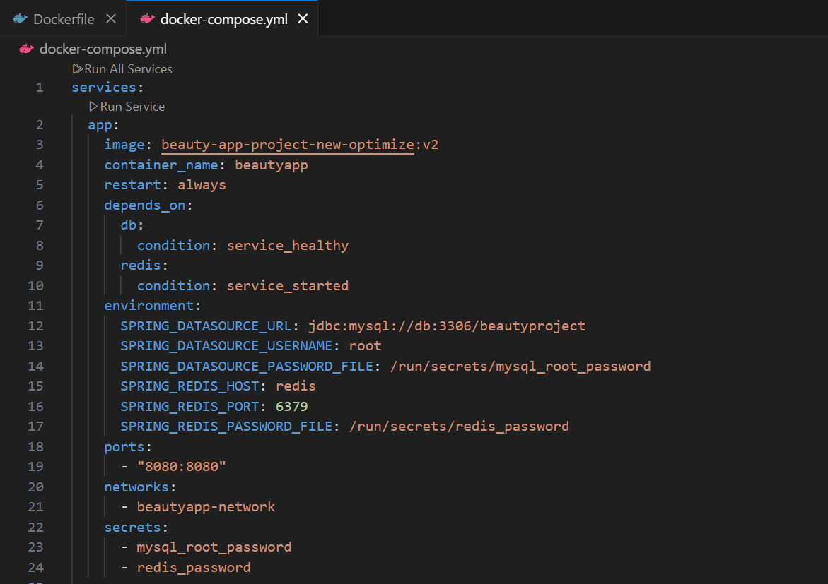
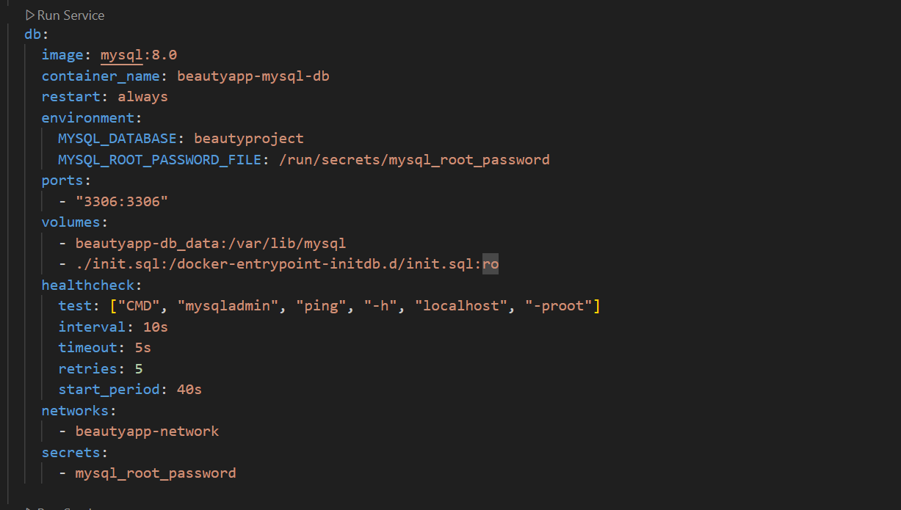
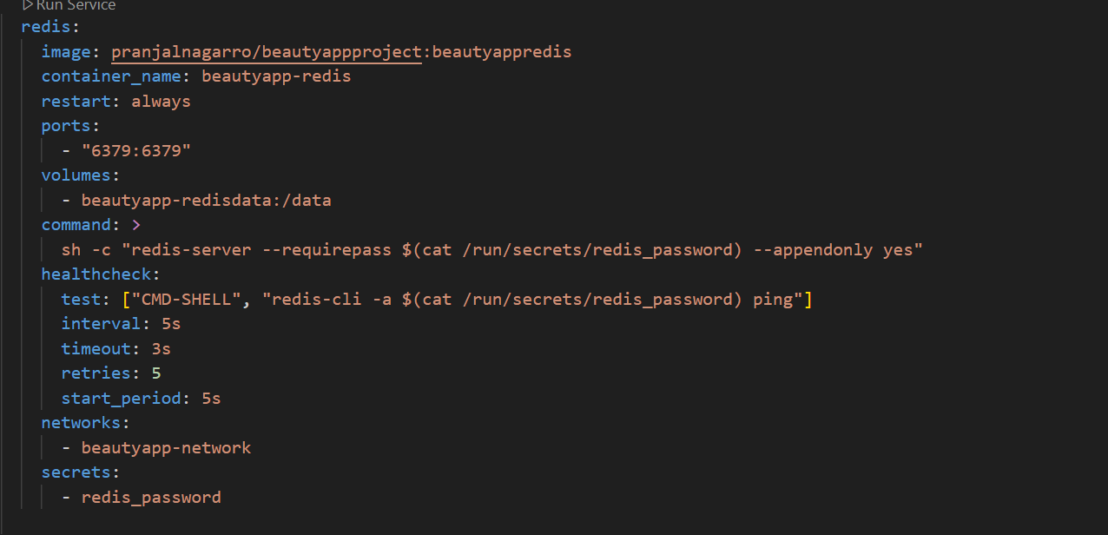
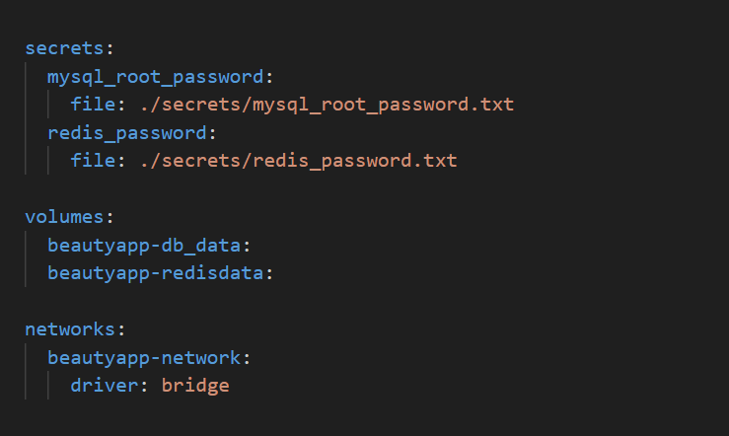
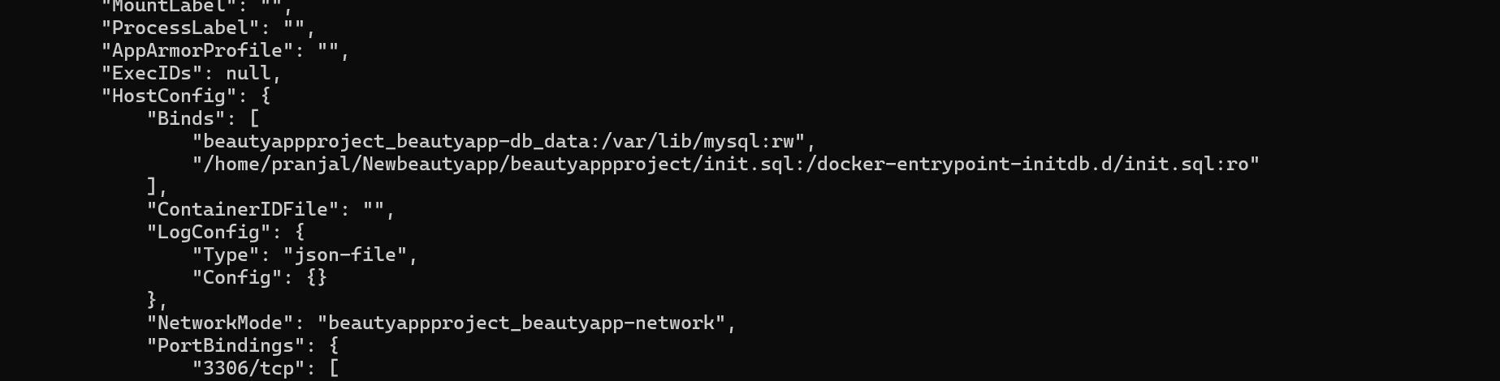
• Use Docker commands to inspect and manage the network.
Created a custom Docker bridge network named beautyapp-network to enable internal communication between the Beauty Products application, MySQL database, and Redis instance. This setup ensures container-level isolation and prevents unintended access from external networks.
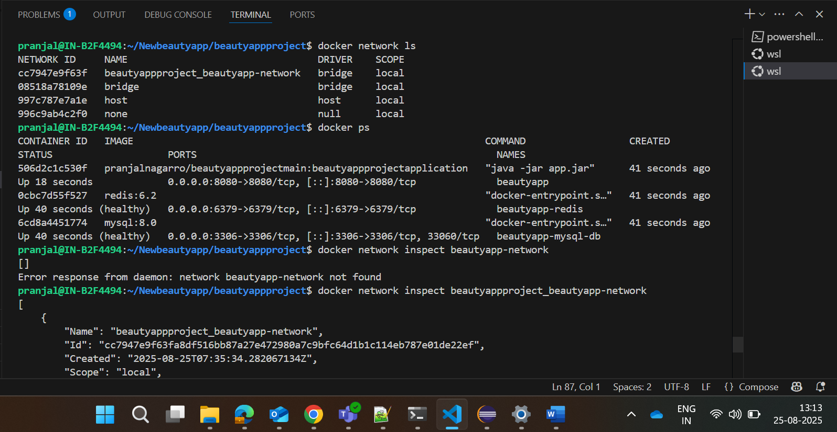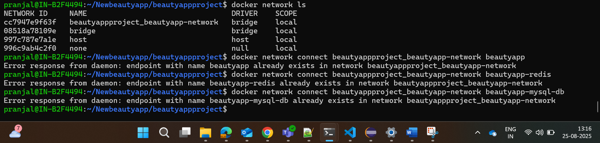
Application is running fine, with MySQL and redis connectivity with custom docker network setup.
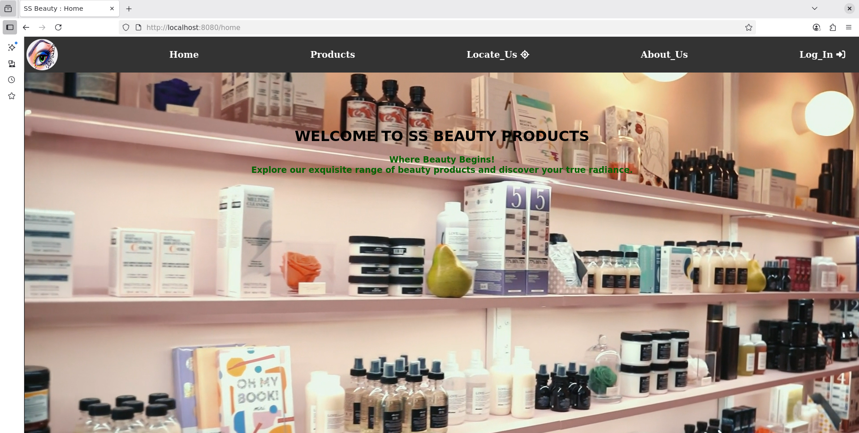
• Create and manage Docker volumes to persist data for your containers.
Two Docker Volumes have been created for persistent storage for our MySQL DB and Redis Container named “beautyapp-db_data” “beautyapp-redisdata”


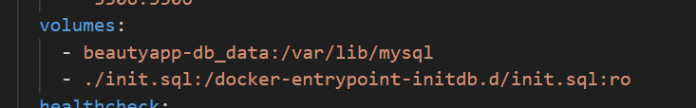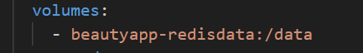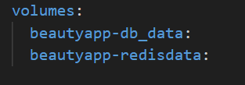
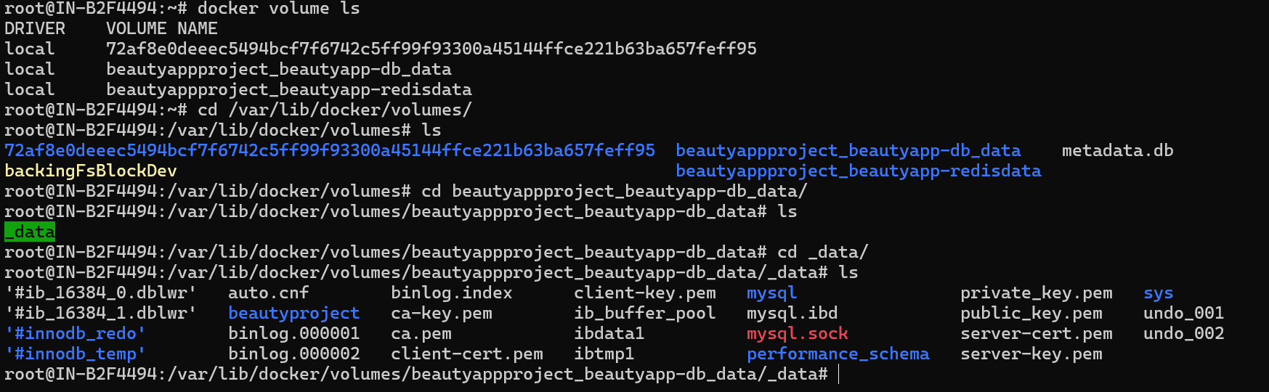
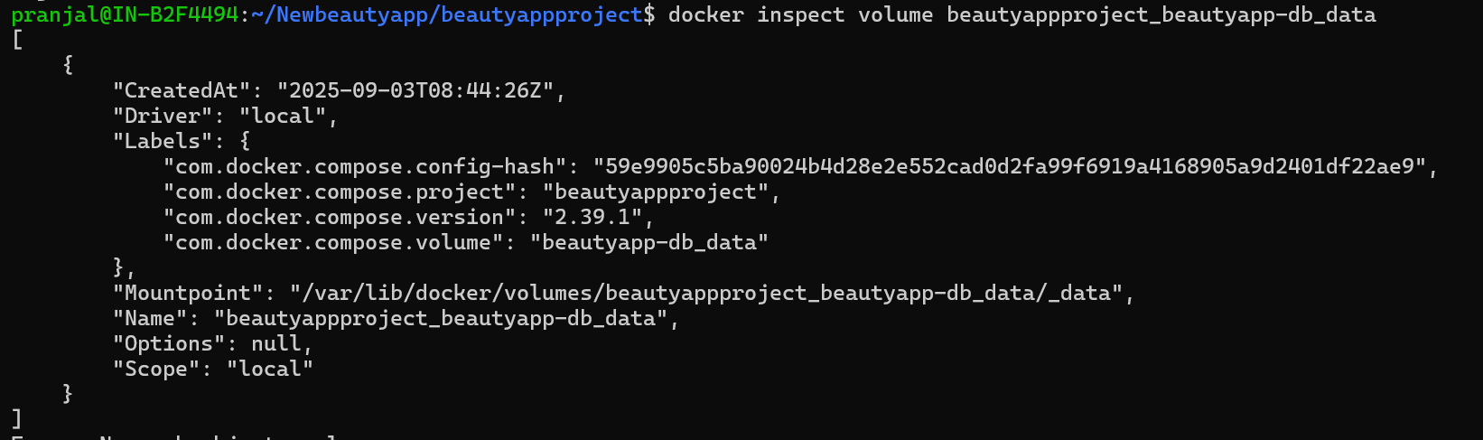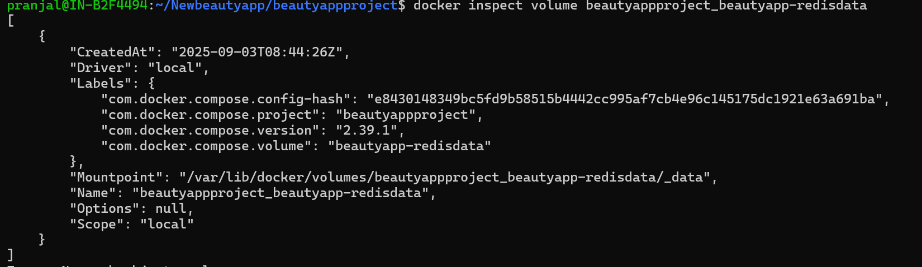
• Use named volumes and bind mounts and demonstrate how they can be used in a multi-container setup.
Created two named volumes for MySQL DB and Redis for persistent storage so as to be used in a multi-container setup. Here’s the snapshot of my docker-compose.yml file for volume setup and mount points of my containers to the named volumes.



• Backup and restore data from Docker volumes.
Old Data Which Needs to Be Restored:
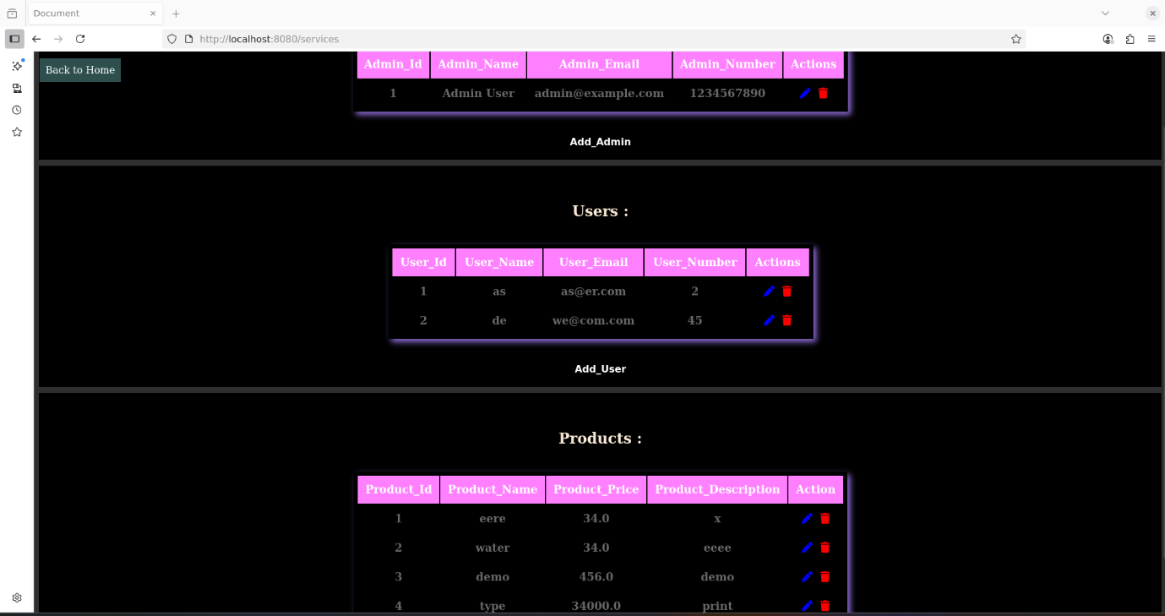
Process to create backup .tar for docker volume /_data dir for MySQL DB:
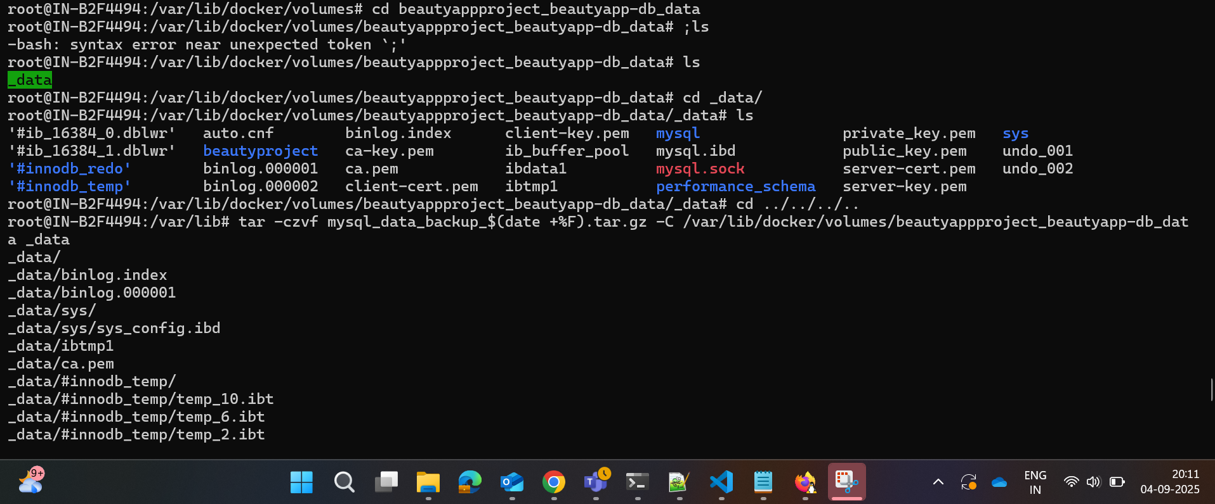
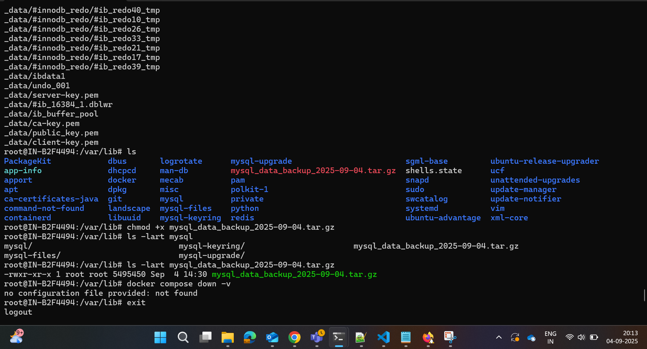
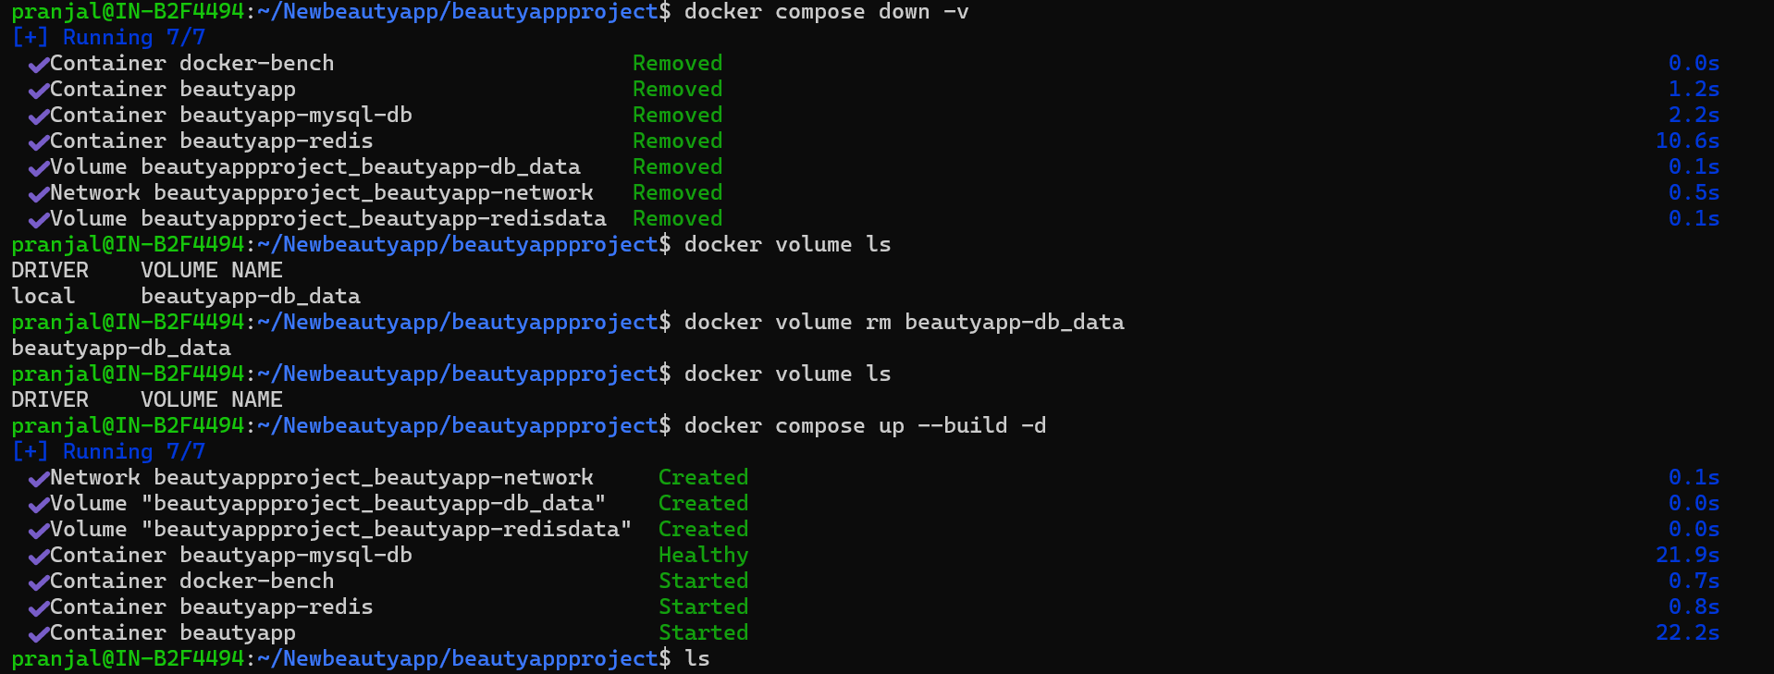
New Containers created , now will restore into the new docker volume of MySQL DB to have the exact values and the old data will be restored.
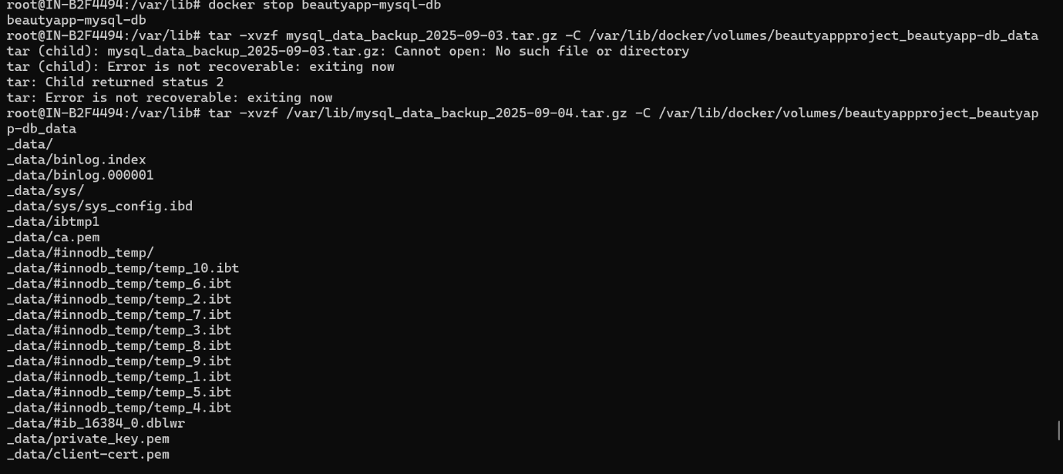
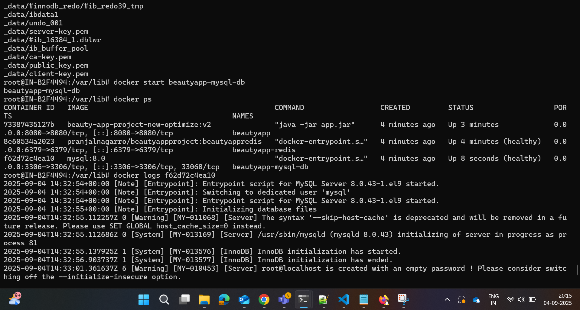
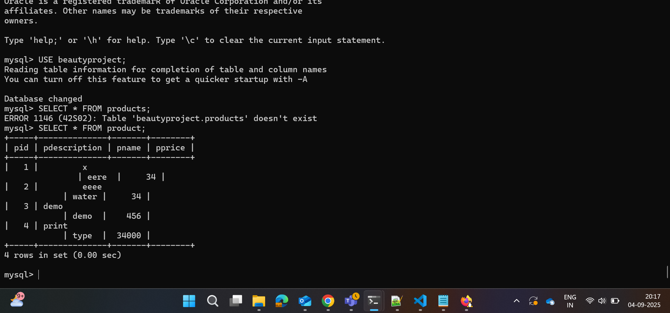
Tables has been restored into the new db docker volume let’s check the application for the exact values
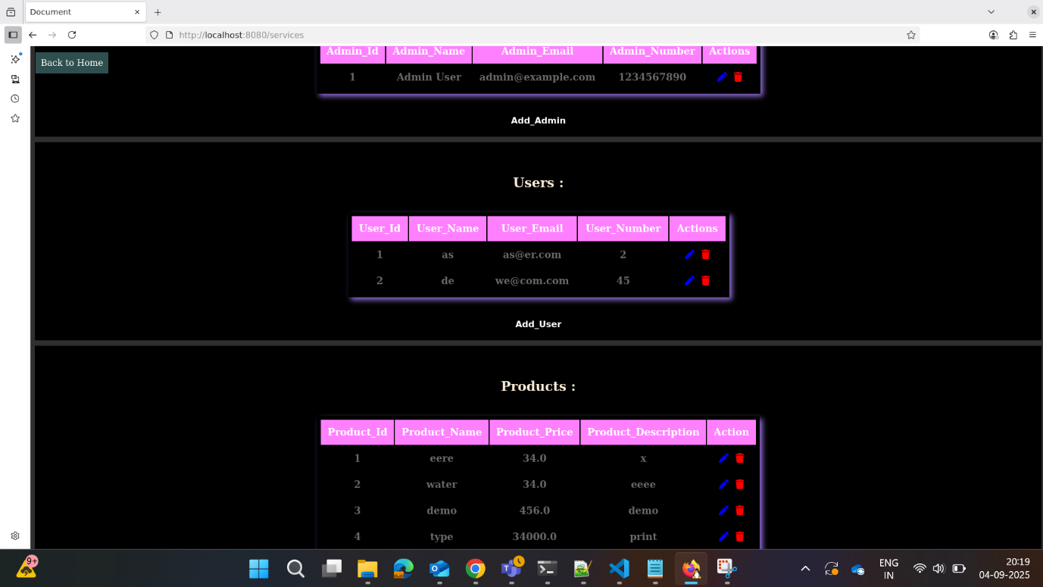
Implement security best practices in your Docker setup, including user permissions, image vulnerability scanning, and secret management.
Including User Permission – Created an USER appuser and added that as non-root user.
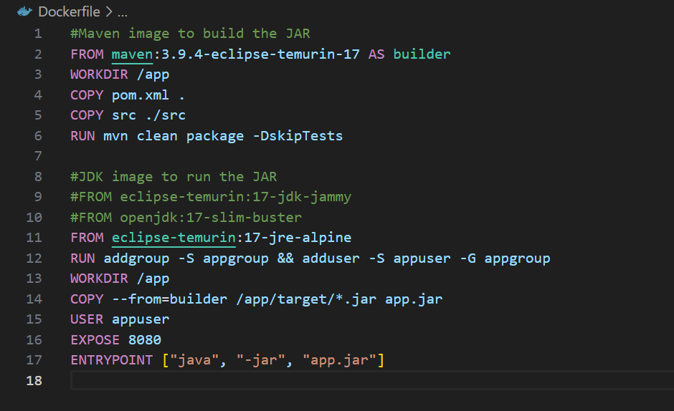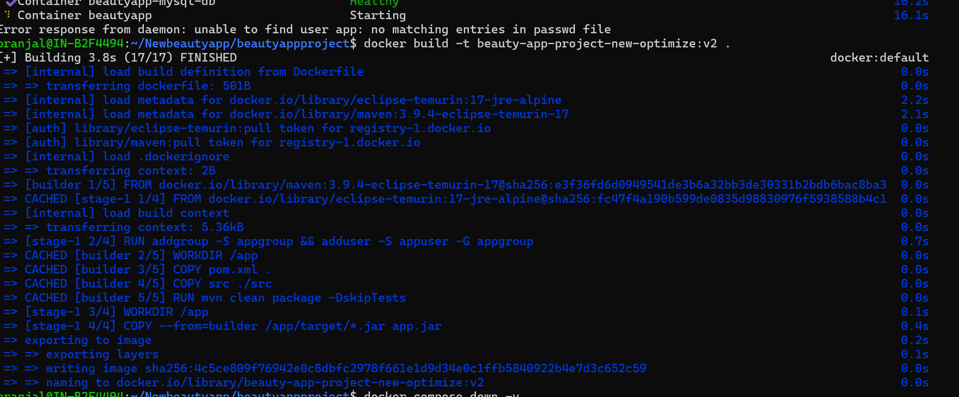
AppUser user was not able to access other files.
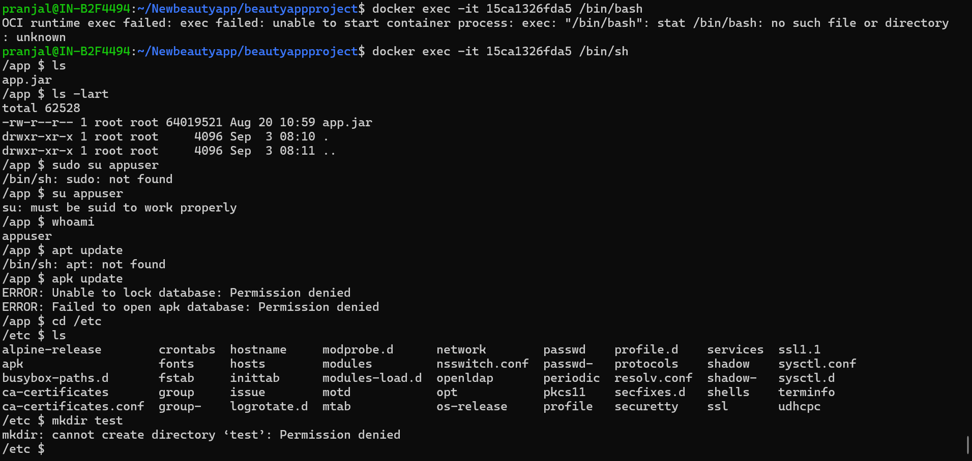
Used AquaSec Trivy Images for Image Vulnerablity Testing :
Here is the command to test your Docker Images using Trivy Image Scanning tool.
[[ docker run --rm -v /var/run/docker.sock:/var/run/docker.sock -v $(pwd)/reports:/reports aquasec/trivy image beauty-app-project-new-optimize:v2 -f table -o /reports/scan.txt ]]
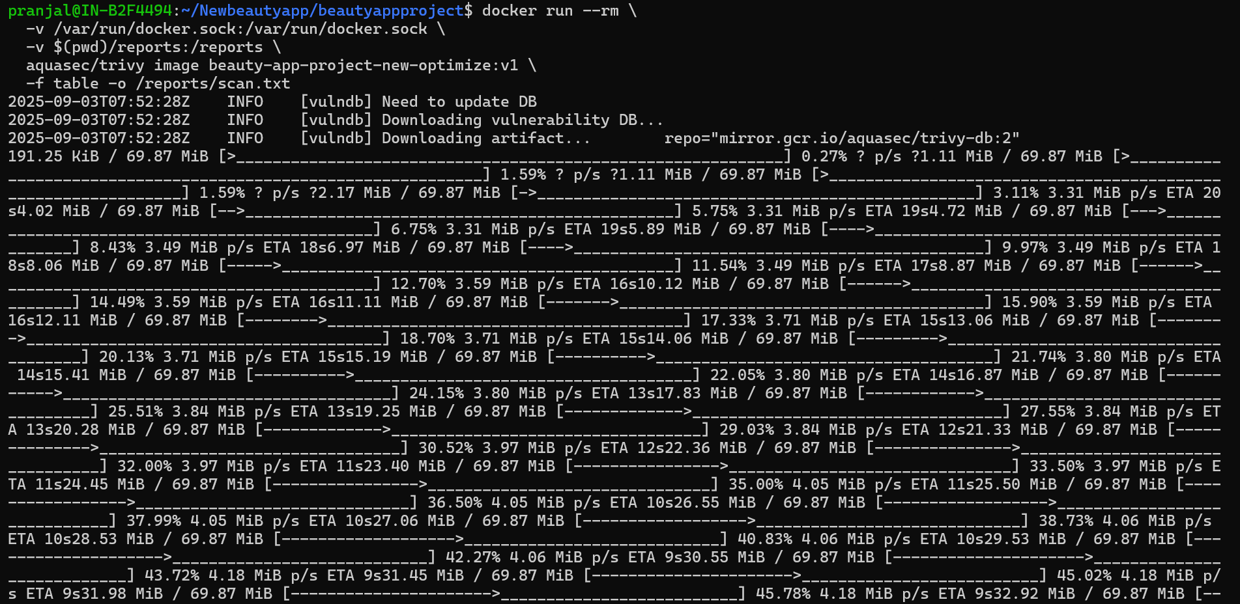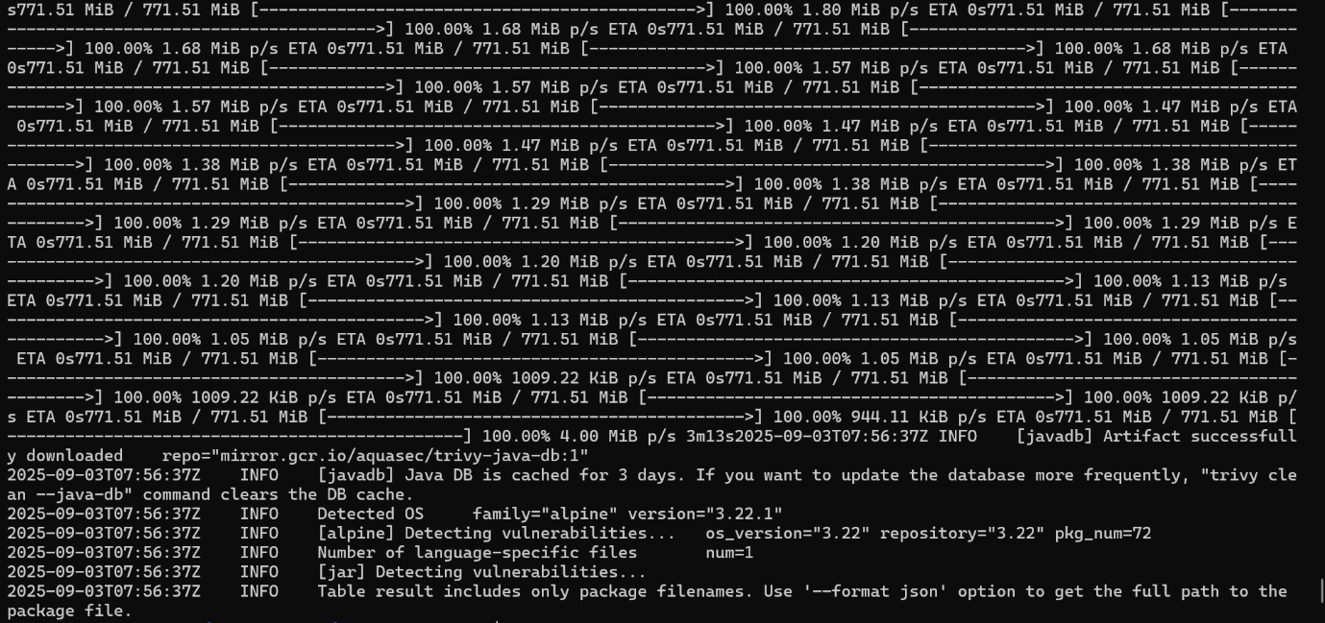
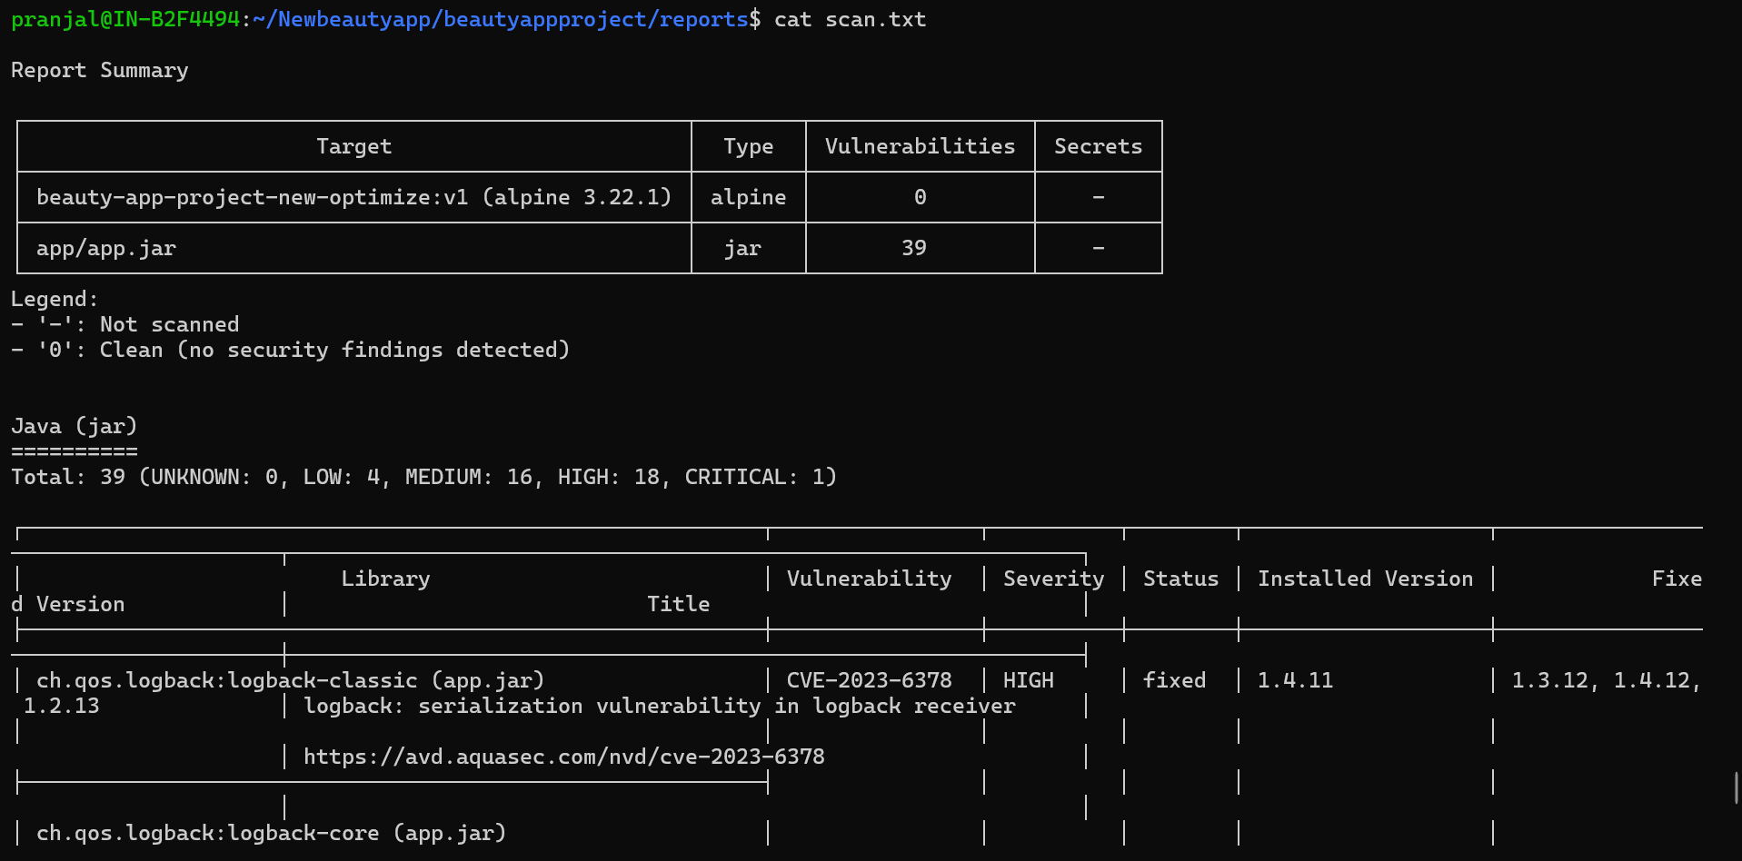
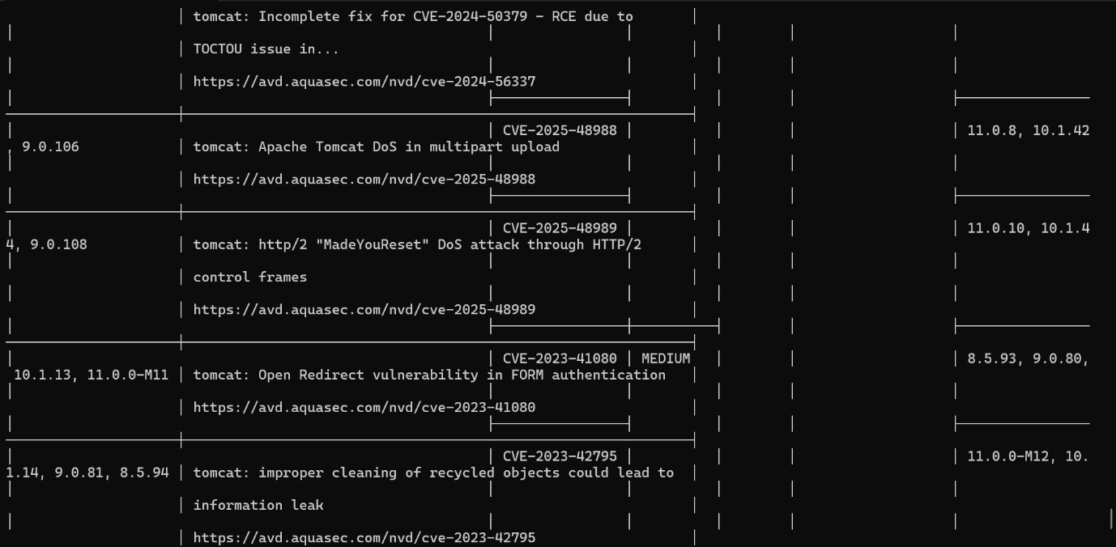
Secret Management:
Created two containers for securing MySQL DB password and Redis password in docker-compose.yml file so that it can directly read from secret files.
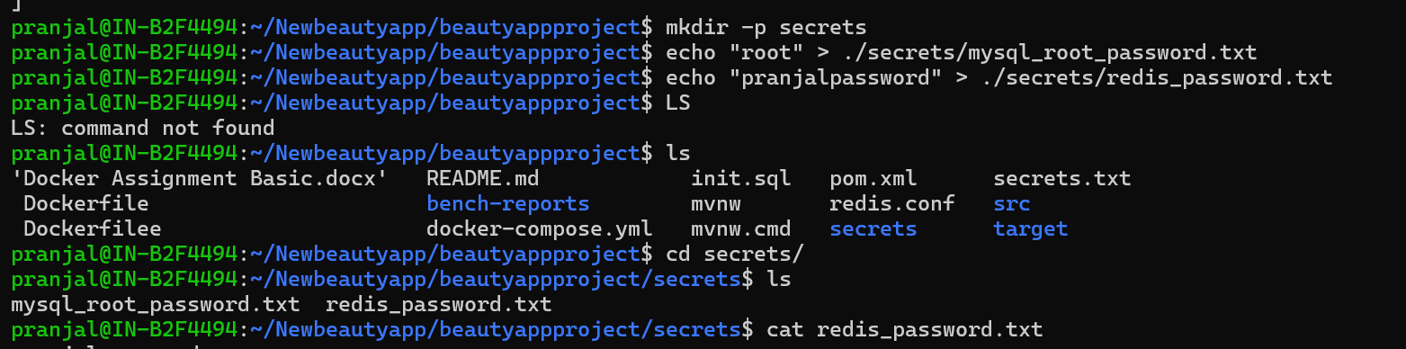
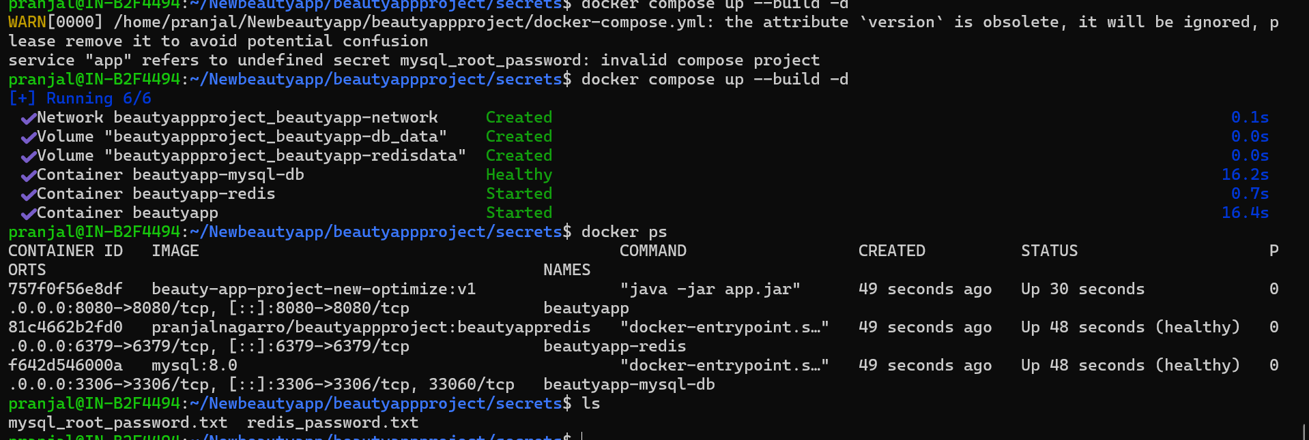
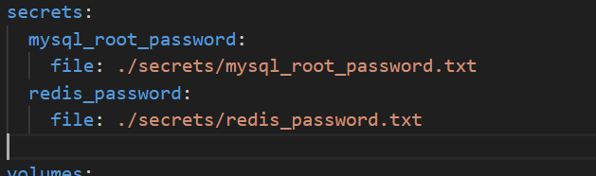
Secrets have been mounted for both redis and MySQL DB here is an reference that shows that secret has been mounted to the respective containers
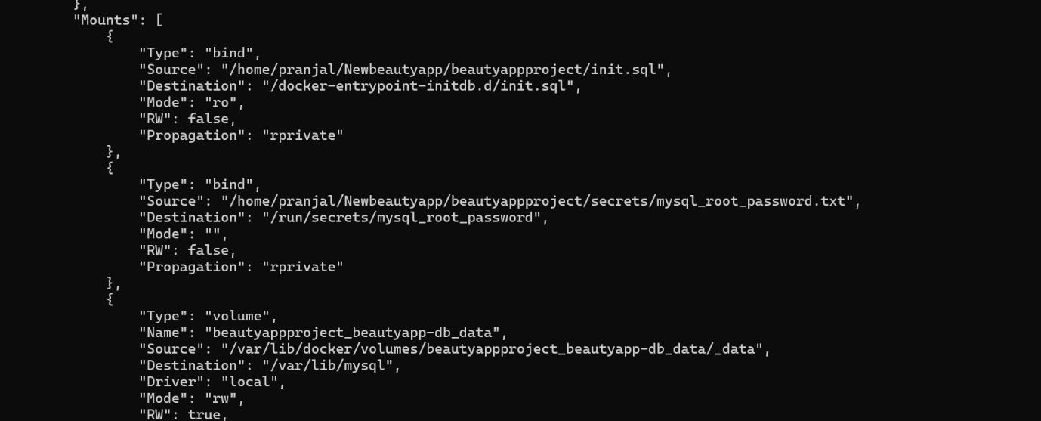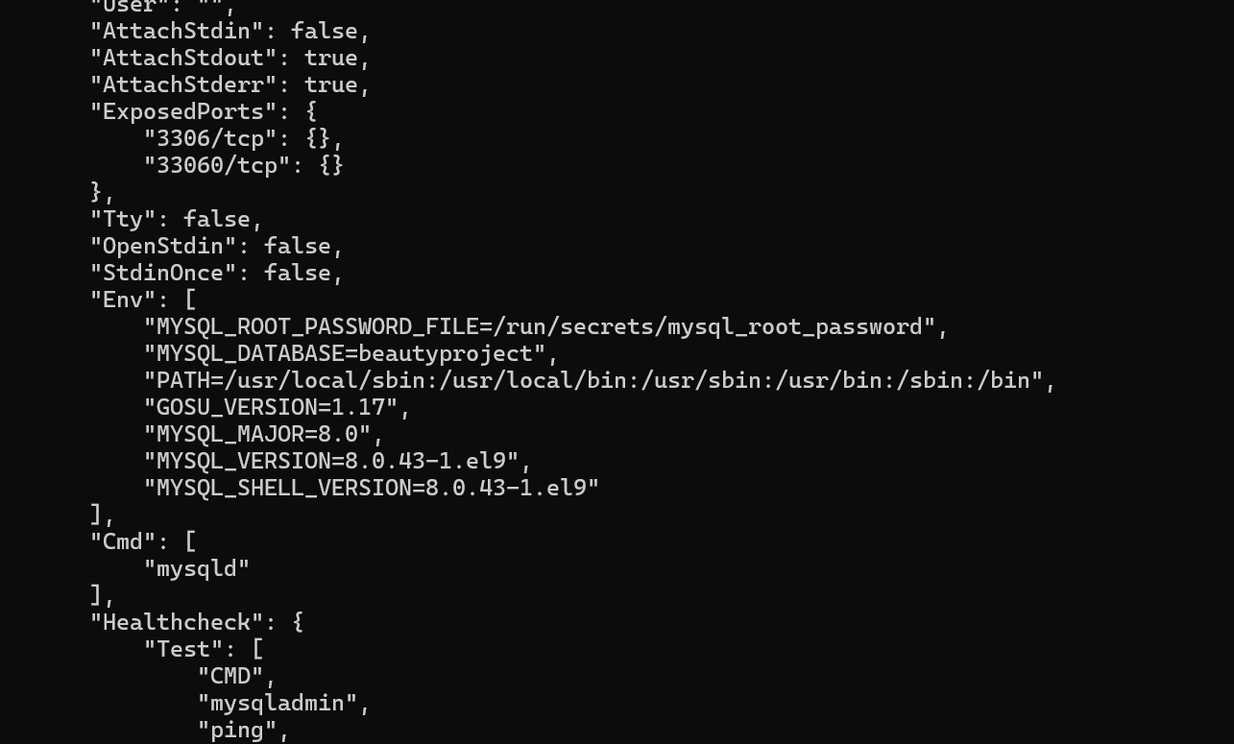
• Configure Docker to run containers with the least privilege.
Configured my Docker to run containers with the least privilege .
cap_drop & cap_add: It explicitly drop all the capabilities and only add those which are required.
security_opt: Non-root users can escalate to root inside a container using setuid binaries. Hence, we can prevent this from no-new-privileges keeping it true. SO non-root users can not use sudo inside the container and perform actions.
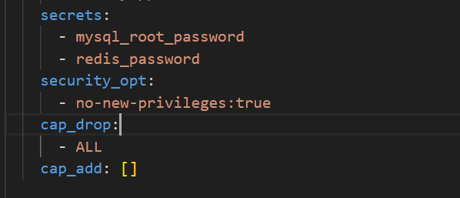
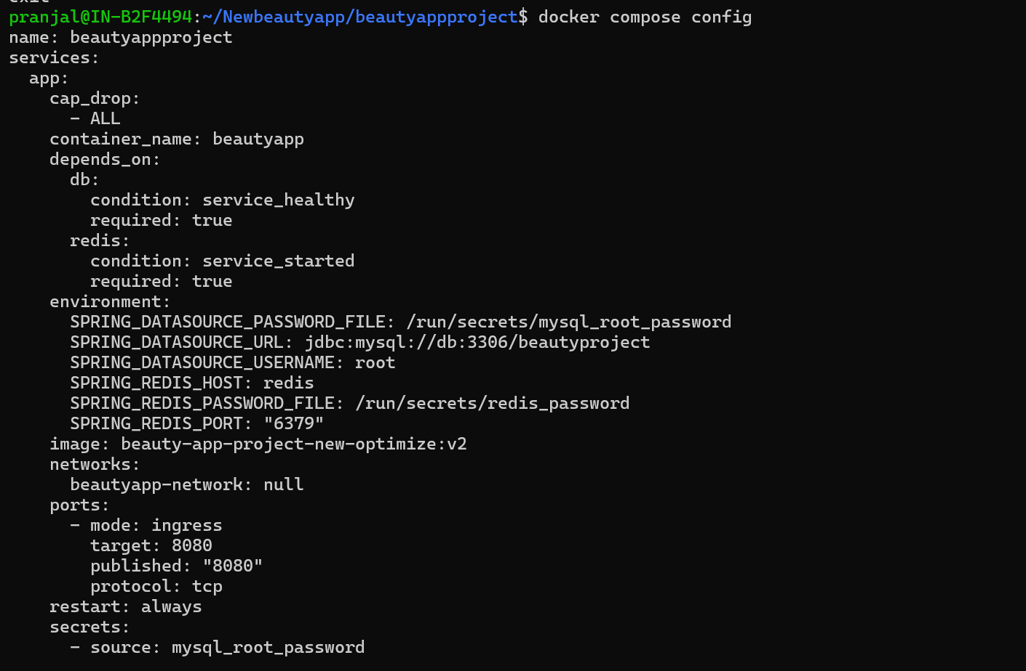
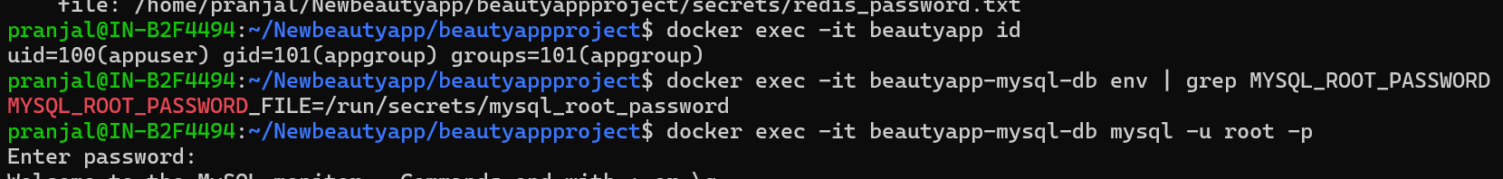
• Use tools like Docker Bench for Security to audit your Docker environment
Implemented Docker bench as security auditing tool to audit my docker environment in docker-compose.yml and generated the reports for on analysis of security audit done by docker bench shell scripts. The reports generated are can be shown in bench-reports/ in my source code.
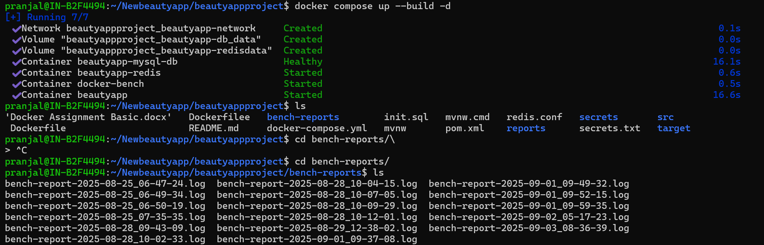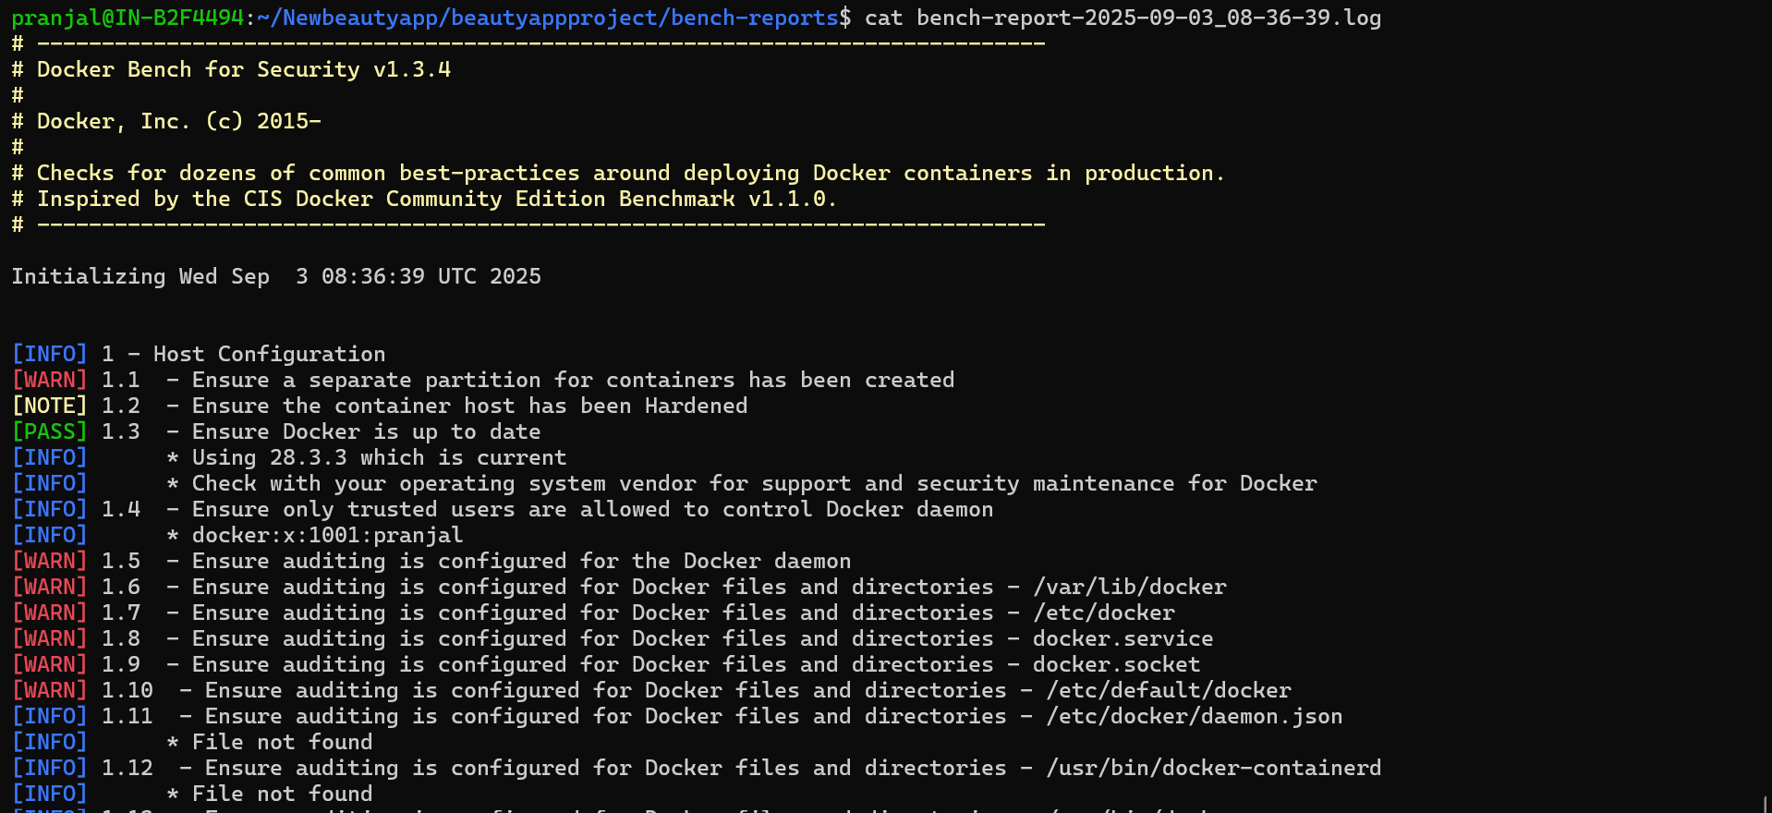
Thank you for reading.

